Main Options
When you select ‘Main Options’ from the DMX’s admin menu or the control panel, you’ll see a panel of options that apply to all DMX modules in the portal.
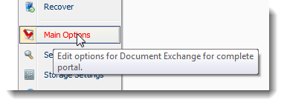
This is split into several sections.

General Options
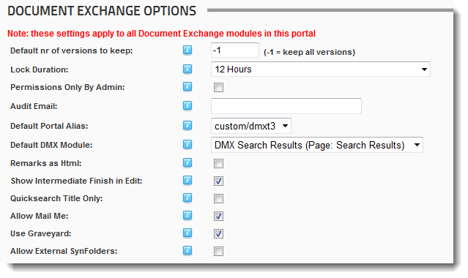

Default nr of versions to keep
Every item that is stored in the document exchange can have multiple versions kept. The number of versions to be kept is set for each item individually, but you can specify a default here.

Lock duration
Locks that users may have on items will time out after a given period. This is set here. A locked item can only be edited by the lock holder or an administrator. The item can still be viewed/downloaded.

Permissions only by admin
You can remove the ability of regular users to set permissions on items. Since permissions propagate by default to children, the administrator can set up the installation to correspond exactly to what the organization wants and let the automated permission setting do the permission setting. Note that you can also set this (permissions only by admin) per folder.

Audit email
If specified audit emails are sent upon every action to this email address. See also the notification help document for details about the notification mechanism.

Default Portal Alias and Default DMX module
Whenever a notification is sent to someone, a link to a document can be included. Because DMX shares its content across the portal, a document can be retrieved at any DMX module instance in the portal. However, the module and page’s visibility settings override any settings on items in the document exchange (i.e. when a page is invisible to a user, that user cannot go to that page to see a document even though that user might have permission to download that document). To make optimal use of DMX notifications specify which DMX instance is the most ‘public’ in your portal; i.e. one that has as view permissions either ‘All Users’ or ‘Registered Users’. That module will be linked to in the emailed notifications so that users can see the document immediately.
NOTE: Even when a user requests a document outside the selected root for the given module, that document will show up. The only consequence is that the folder tree to the left will not be constructed to the document.

Best Practice/Tips
Set up a DMX on either a public page (if your site has any) or a page for registered users (so all can see it). Then create a folder in your folder tree called “Public” or whatever you wish and select that as that DMX’s root folder. Finally switch to Templated view and set it to a minimal template (see templating documentation). If you wish you could even decide to hide the page from the menu so users only land on it through direct links and not by browsing the site.
Now whenever a link is sent by the notifications engine the user is taken to this page where he/she will only see this document (remember that a requested document is shown even if it lies outside the root). The user may need to log in to be able to see the document if it is not visible to All Users.

Remarks as Html
Every item in the Document Exchange can have remarks in the meta data. By checking this box the editor for this is an Html editor and the remarks will then be stored and rendered as Html.

Show Intermediate Finish in Edit
This applies only to the wizard edit interface. If selected then the user is shown “Finish” throughout the wizard allowing him/her to finish the editing and commit changes at any stage. If you uncheck this box, the user has to go through all steps, even the non-essential ones, before he/she can click ‘Finish’.

Quicksearch Title Only
Search is implemented in several ways. There is a search button in the Ajax UI which brings up a dialog which has several visible options. Alternatively you can add a DMX to the Search Results page of your DNN site so that users are shown search results not just from DNN but also from DMX on this page. With this option you tell DMX to only search the title if a user uses the DNN inbuilt search box. If unchecked then it searches title, remarks, keywords, and contents.

Allow Mail Me
This setting allows users to email themselves documents. If the checkbox is unchecked, they will not see the menu item to do this.

Use Graveyard
If selected then any hard deleted item is written to a folder on the server’s hard disk called the graveyard. This allows you to recuperate any accidentally hard deleted items (using the recover screen on the admin menu). If unchecked then hard deleted items are deleted forever.

Allow External Sync Folders (Visible only to Host)
Sync folders are DMX folders that are synchronized with a folder somewhere on the server. If selected Administrators of the portal can specify folders that lie outside of the portal. Note this has security consequences! In principle a portal should always be restricted to its own environment in DNN and an admin should never have access to any other folder.

Application Permissions
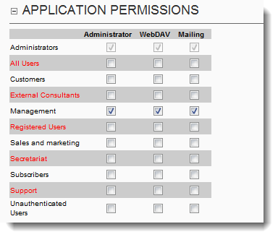
You can grant various application permissions to the portal’s security roles here. Again, this has a portal-wide effect.

Administrator Permission
The selected roles will be able to access all content within the module plus most functions (editing of categories/attributes). The only difference with the Administrator is that the latter can set the Main options of DMX and the providers (Upload/Storage). I.e. the latter can set the mostly technical aspects whereas the doc admin can manage all things related to content.

WebDAV Permission
If WebDAV is enabled on the portal you can specify who has access to this functionality. Note that access for non-authorized users (i.e. someone not logged in) doesn’t work. So selecting All/Unauthorized Users is not advised here.

Mailing Permission
Document Exchange includes a powerful mailing engine which allows a user to email content to others. Here you set who is allowed to use this function. Since the risk of spam is elevated with this function, we advise against allowing non-authorized/all users access to this.

Permission Edit Permissions
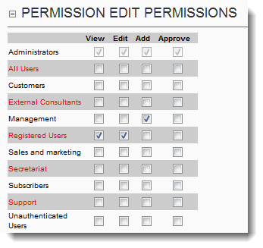
When editing an item the user is optionally shown a matrix of checkboxes to set permissions. Some of these checkboxes may be reserved so not everyone can select them. For instance, the approval checkbox will effectuate the approval workflow on all content in the folder so you may want to be conservative about who gets to set that. For that reason by default DMX allows regular users to only select the VIEW and EDIT permissions and reserves the ADD and APPROVE permission checkboxes for Administrators. Here you can specify exactly who gets access to which checkboxes.

WebDAV Settings

Enable WebDAV
If webDav is installed (see relevant documentation), the administrator can still decide to remove this mechanism just for this portal.

WebDAV Hard Deletes
If checked then a delete through webdav will effectively remove the item entirely from the DMX without any possibility for recovery. If unchecked the item remains but invisible to regular users. The advantage of leaving it unchecked is that you have a guarantee that no item gets hard deleted. But a downside is that an item will remain invisible but there. So when a user drops in a new document with the same name, the old one gets revived and becomes an older version of the newly dropped in document.

Configuration (Host Only)
This section is only visible to SuperUsers and affects ALL DMX instances of the entire DNN installation.

Debug Mode
If checked the DMX will operate in ‘debug mode’ which means it will write more to logging files and will write some debugging files to disk upon user actions. It can be that we ask you to use this feature to analyze problems that you might be experiencing.

Thumbnail Settings
Document Exchange includes the option to set thumbnails per item. For image file types DMX will attempt to auto-generate a thumbnail based on the settings below. For others the user can upload a thumbnail while editing an entry to serve as thumbnail.
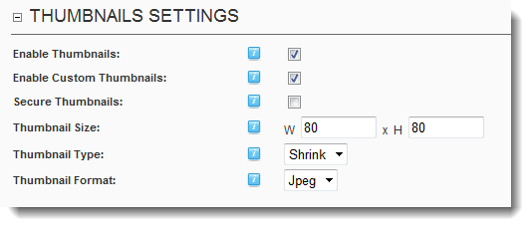
If you alter the settings it does not affect existing content. But under Admin > Run Scripts there is a script to regenerate thumbnails for the portal. So if you alter the size/method settings you’ll probably want to run this script. Note this script only alters the automatically generated thumbnails. It can’t do anything with custom thumbnails.

Enable Thumbnails
If disabled users will never see anything related to thumbnails in the UI and DMX will not generate any thumbnails either.

Enable Custom Thumbnails
If selected users can upload a custom thumbnail. If not selected only the automatically generated thumbnail will be used.

Secure Thumbnails
Is elected the generated thumbnail becomes an entry in DMX itself so it is stored in a secure fashion. If you leave this unchecked the thumbnail receives a random name and is placed under Portals/[id]/DMX/Thumbnails. The latter means there is less overhead when using thumbnails and will perform faster.

Thumbnail Size
Specify the thumbnail box in pixels.

Thumbnail Type
This tells DMX how to resize the image to fit the box. It can either “shrink” to fit the box which may leave empty spaces above/below or to the sides. Or it can “Crop” the thumbnail which will shrink the image but opt to cut off above/below/sides. Or finally it can “Fill” the box which may distort the image. The former two methods preserve aspect ratio. The latter two will always output a thumbnail with the dimensions of the bounding box.

Thumbnail Format
You can specify the image format to use for the thumbnails.

Mailing Options
As mentioned before the module includes a powerful mailing engine. Here you set what the users see and can edit.
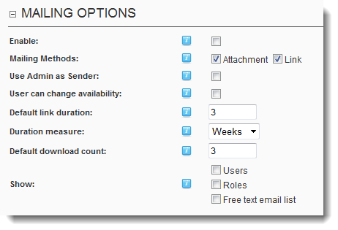
If disabled this function will not be visible to the users. Note you also need to set the Application permission for this function (see above).

Mailing Methods
The user is given a choice if both are selected. The “attachment” option will send all the emails with the document(s) attached. The “link” option sends the emails with a link to the site which begins download of the file. The link includes a unique key that tells DMX it can bypass security and serve the file. This key will expire after x amount of time and/or downloads.
Note: if you select neither the mailing function will not work.

Use Admin As Sender
If selected the sender of the email will be whoever is selected as Administrator in the site’s settings. If left unchecked then the sender will be the current user (i.e. the one mailing).

User Can Change Availability
This is relevant for links only. If selected the user can change the availability (time/nr downloads) him/herself. If left unchecked the default options are used.

Default Link Duration/Measure/Download Count
Select how long the link remains “alive”. After this time the link will generate a NOT FOUND error when tried.

Show
The sending user can select addressees in a number of ways.

Users
The user can add users through username to a list of addressees. Note this requires the user to be aware of user’s usernames.

Roles
This is a very powerful option so use with care. It allows the user to select roles to send to. ALL users in that role will receive the email.

Free Text Email List
Allows the sender to specify a list of email addresses to send to. Note that the email can include so-called tokens like [User:FirstName] which become useless if this is not a user in the portal. So DMX will try to match the email addresses in this list to users in the portal so the tokens could still work if the email address belongs to a known user.
Note if you select neither one of the above options the mailing function doesn’t work.

